Department Store Announcements

Listen to three announcements in a shopping centre. While listening, match the following pictures with the correct announcement. Write the number of the announcement (1-3) in the table below. There is one picture that you will not need.
You now have 10 seconds to look at the task.
You will hear the recording once only.
announcements
pictures | 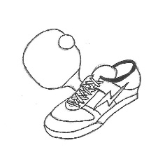 |  | 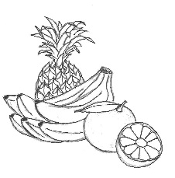 | 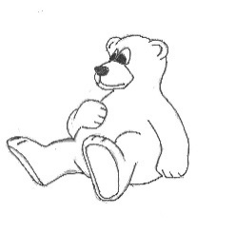

(Quelle: Ministerium für Bildung Sachsen-Anhalt, Zentrale Klassenarbeit 2016 Gymnasium Englisch Schuljahrgang 6; Illustrationen: W.Weiwad)

