A Riddle
Listen to a person talking about different animals. While listening, match the animals (1 to 6) with one of the pictures (A to I). There are three more pictures than you need.
You will hear the recording once only.

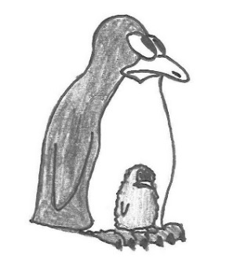 |  | 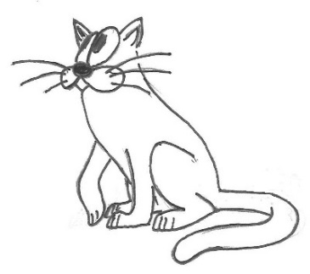
A | B | C

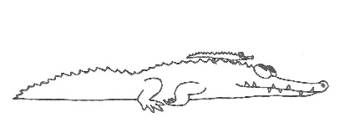 | 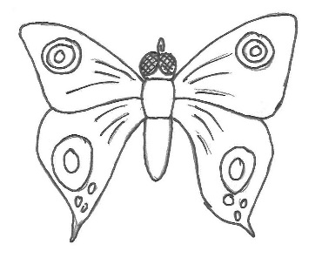 | 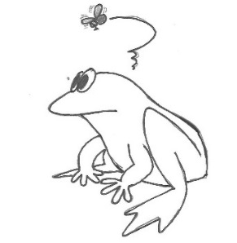
D | E | F

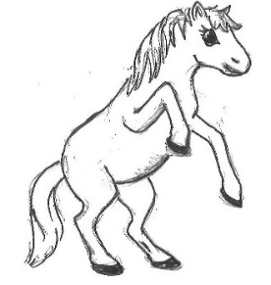 | 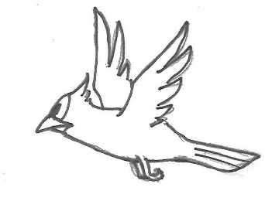 | 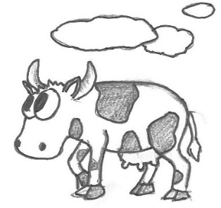
G | H | I

Animal | 1 | 2 | 3 | 4 | 5 | 6
Picture

(Quelle: Ministerium für Bildung Sachsen-Anhalt, Zentrale Klassenarbeit 2018 Sekundarschule Englisch Schuljahrgang 6; Illustrationen: W. Weiwad)

